.NET Core: Developing Cross-Platform Web Apps with ASP.NET Core – Workshop*PLUS*

Module 1: Overview

Student Lab Manual

Instructor Edition (Book Title Hidden Style)

Version 3.0

**Conditions and Terms of Use**

**Microsoft Confidential**

This training package is proprietary and confidential, and is intended only for uses described in the training materials. Content and software is provided to you under a Non-Disclosure Agreement and cannot be distributed. Copying or disclosing all or any portion of the content and/or software included in such packages is strictly prohibited.

The contents of this package are for informational and training purposes only and are provided "as is" without warranty of any kind, whether express or implied, including but not limited to the implied warranties of merchantability, fitness for a particular purpose, and non-infringement.

Training package content, including URLs and other Internet Web site references, is subject to change without notice. Because Microsoft must respond to changing market conditions, the content should not be interpreted to be a commitment on the part of Microsoft, and Microsoft cannot guarantee the accuracy of any information presented after the date of publication. Unless otherwise noted, the companies, organizations, products, domain names, e-mail addresses, logos, people, places, and events depicted herein are fictitious, and no association with any real company, organization, product, domain name, e-mail address, logo, person, place, or event is intended or should be inferred.

© 2019 Microsoft Corporation. All rights reserved.

**Copyright and Trademarks**

© 2019 Microsoft Corporation. All rights reserved.

Microsoft may have patents, patent applications, trademarks, copyrights, or other intellectual property rights covering subject matter in this document. Except as expressly provided in written license agreement from Microsoft, the furnishing of this document does not give you any license to these patents, trademarks, copyrights, or other intellectual property.

Complying with all applicable copyright laws is the responsibility of the user. Without limiting the rights under copyright, no part of this document may be reproduced, stored in or introduced into a retrieval system, or transmitted in any form or by any means (electronic, mechanical, photocopying, recording, or otherwise), or for any purpose, without the express written permission of Microsoft Corporation.

For more information, see Use of Microsoft Copyrighted Content at  
[*http*://www.microsoft.com/about/legal/permissions/](http://www.microsoft.com/about/legal/permissions/)

Internet Explorer, Microsoft, Visual Studio, and Windows are either registered trademarks or trademarks of Microsoft Corporation in the United States and/or other countries. Other Microsoft products mentioned herein may be either registered trademarks or trademarks of Microsoft Corporation in the United States and/or other countries. All other trademarks are property of their respective owners.

Contents

Lab 1: Visual Studio and ASP.NET Core Overview 1

Exercise 1: Create a New ASP.NET Core Application 4

Exercise 2: Middleware 11

Exercise 3: Working Environments 17

# Lab 1: Visual Studio and ASP.NET Core Overview

#### Introduction

ASP.NET Core is a new open-source and cross-platform framework for building modern cloud-based Web applications using Microsoft .NET Framework. We built it from the ground up to provide an optimized development framework for apps that are either deployed to the cloud or run on-premises. It consists of modular components with minimal overhead, so you retain flexibility while constructing your solutions. You can develop and run your ASP.NET Core applications cross-platform on Windows, Mac and Linux. ASP.NET Core is fully open source on GitHub.

The first preview of ASP.NET 1.0 was released almost 15 years ago. Since then millions of developers have used it to build and run great web applications, and over the years, we have added and evolved many capabilities to it.

With ASP.NET Core, we are making a number of architectural changes that make the core web framework much leaner and more modular. ASP.NET Core is no longer based on System.Web.dll, but is instead based on a set of granular and well factored NuGet packages allowing you to optimize your app to have just what you need. You can reduce the surface area of your application to improve security, reduce your servicing burden, and also to improve performance in a true pay-for-what-you-use model.

ASP.NET Core is built with the needs of modern Web applications in mind, including a unified story for building Web UI and Web APIs that integrate with today’s modern client-side frameworks and development workflows. ASP.NET Core is also built to be cloud-ready by introducing environment-based configuration and by providing built-in dependency injection support.

To appeal to a broader audience of developers, ASP.NET CORE supports cross-platform development on Windows, Mac and Linux. The entire ASP.NET CORE stack is open source and encourages community contributions and engagement. ASP.NET CORE comes with a new, agile project system in Visual Studio while also providing a complete command-line interface so that you can develop using the tools of your choice.

In summary, with ASP.NET Core, you gain the following foundational improvements:

* New light-weight and modular HTTP request pipeline
* Ability to host on IIS or self-host in your own process
* Built on .NET Core, which supports true side-by-side app versioning
* Ships entirely as NuGet packages
* Integrated support for creating and using NuGet packages
* Single aligned web stack for Web UI and Web APIs
* Cloud-ready environment-based configuration
* Built-in support for dependency injection
* New tooling that simplifies modern web development
* Build and run cross-platform ASP.NET apps on Windows, Mac and Linux
* Open source and community focused

**.NET Core**

.NET Core is a modular runtime and library implementation that includes a subset of the .NET Framework. .NET Core consists of a set of libraries, called “CoreFX”, and a small, optimized runtime, called “CoreCLR”. .NET Core is open-source, so you can follow the progress on the project and contribute to it on GitHub:

* .NET Core Libraries (CoreFX)
* .NET Core Common Language Runtime (CoreCLR)

The CoreCLR runtime (Microsoft.CoreCLR) and CoreFX libraries are distributed via NuGet. The CoreFX libraries are factored as individual NuGet packages according to functionality, named “System.[module]” on nuget.org.

One of the key benefits of .NET Core is its portability. You can package and deploy the CoreCLR with your application, eliminating your application’s dependency on an installed version of .NET (for example, .NET Framework on Windows). You can host multiple applications side-by-side using different versions of the CoreCLR, and upgrade them individually, rather than being forced to upgrade all of them simultaneously.

CoreFX has been built as a componentized set of libraries, each requiring the minimum set of library dependencies (for example, System.Collections only depends on System.Runtime, not System.Xml). This approach enables minimal distributions of CoreFX libraries (just the ones you need) within an application, alongside CoreCLR. CoreFX includes collections, console access, diagnostics, IO, Language Integrated Query (LINQ), JavaScript Object Notification (JSON), XML, and regular expression support, just to name a few libraries. Another benefit of CoreFX is that it allows developers to target a single common set of libraries that are supported by multiple platforms.

When .NET Framework first shipped in 2002, it was a single framework, but it did not take long before the .NET Compact Framework shipped, providing a smaller version of .NET Framework designed for mobile devices. Over the years, this exercise was repeated multiple times, so that today there are different flavors of .NET Framework specific to different platforms. Add to this, the further platform reach provided by Mono and Xamarin, which target Linux, Mac, and native iOS and Android devices. For each platform, a separate vertical stack consisting of runtime, framework, and app model is required to develop .NET applications. One of the primary goals of .NET Core is to provide a single, modular, cross-platform version of .NET that works the same across all of these platforms. Since .NET Core is a fully open source project, the Mono community can benefit from CoreFX libraries. .NET Core will not replace Mono, but it will allow the Mono community to reference and share, rather than duplicate, certain common libraries, and to contribute directly to CoreFX, if desired.

In addition to being able to target a variety of different device platforms, there was also pressure from the server side to reduce the overall footprint, and more importantly, surface area, of the .NET Framework. By factoring the CoreFX libraries and allowing individual applications to pull in only those parts of CoreFX, they require (a so-called “pay-for-play” model), server-based applications built with ASP.NET Core to minimize their dependencies. This, in turn, reduces the frequency with which patches and updates to the framework impact these applications, since only changes made to the individual pieces of CoreFX that is used by the application impact the application. A smaller deployment size for the application is a side benefit, and one that makes more of a difference if many applications are deployed side-by-side on a given server.

#### Objectives

This lab will show you how to:

* Create a new ASP.NET Core application in Visual Studio 2019.
* Compile the application using .NET Core and .NET Framework.
* Work with static files.
* Create custom middleware.
* Use working environments to configure application pipelines.

#### System Requirements

To complete this lab, you need:

* Visual Studio 2019
* .NET Core (download from <https://dot.net>)

#### Estimated Time to Complete This Lab

90 minutes

Exercise 1: Create a New ASP.NET Core Application

#### Objectives

In this exercise, you will:

* Create a new ASP.NET Core application in Visual Studio 2019.
* Run the application using different web servers.

Task 1: Create the Visual Studio Solution

* 1. Open Visual Studio 2019.
  2. Create a new ASP.NET Core application project by going to **File** > **New** > **Project**.
  3. Under templates, go to **Visual C#** > **Web**, and then choose **ASP.NET Core Web Application**.

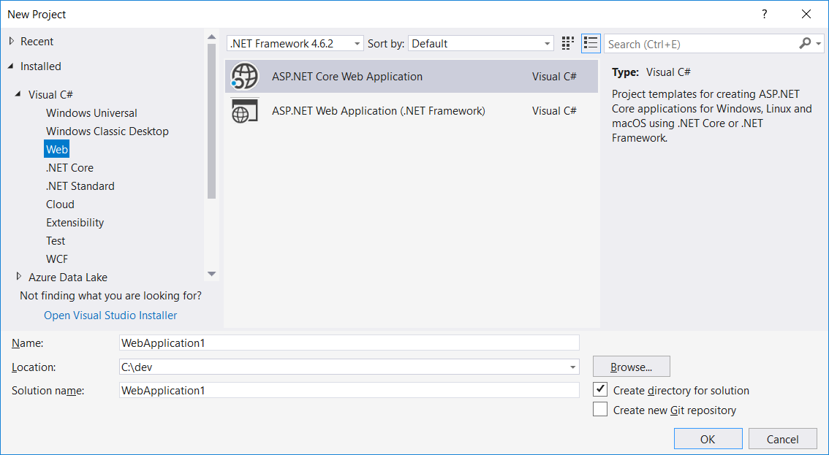

* 1. Name the project *HelloWorld*, and change the location as per your own preferences. Leave the check box selected for **Create directory for solution**. Click **OK**.
  2. Choose Web Application (Model-View-Controller) template and from drop downs select .NET Core / ASP.NET Core 5.0.  
     Make sure that Authentication is No Authentication and Enable Docker Support is cleared.

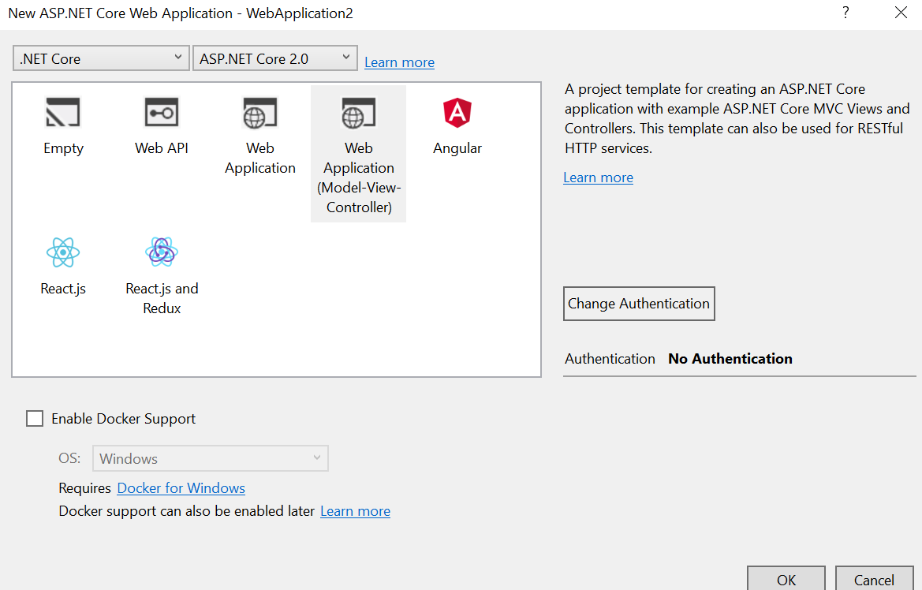

* 1. Click **OK**.
  2. Visual Studio will take a few seconds to restore NuGet packages and setup a project.
  3. Build the application to ensure everything compiles well.

Task 2: Run the Application on Different Web Servers

1. Run the application using **IIS Express**. Go to different application views.

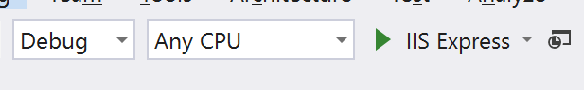

* 1. Take some time to review the following aspects of the project:
* Project file (*.csproj)
* Server-side references:
  + What is the difference between .NET Framework and .NET Core references?
* wwwroot folder
* Client-side dependencies
* Controllers, Models, ViewModels, and Views folders
* Services folder
* appsettings.json
* bundleconfig.json
* bower.json
* project.json – Can you find it?
* Startup.cs

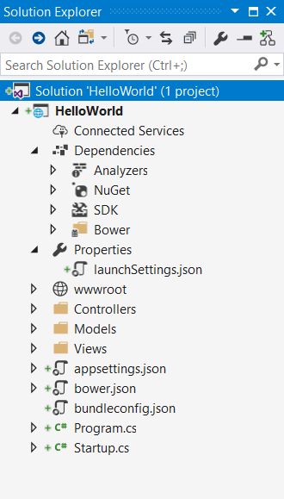

* 1. Now that you are a bit more familiar with ASP.NET Core project template and files involved, let us try to run the application using other web servers: using Kestrel and IIS Express.
  2. Choose **IIS Express** as the hosting server in Visual Studio and run the application.

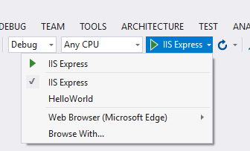

* 1. Visual Studio will deploy your app to IIS Express, which servers as a reverse proxy to Kestrel.

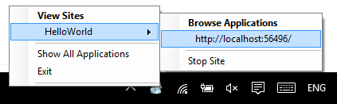

ASP.NET Core is completely decoupled from the web server environment that hosts the application. ASP.NET Core supports hosting in IIS and IIS Express, and self-hosting scenarios using the Kestrel and WebListener HTTP servers. Additionally, developers and third party software vendors can create custom servers to host their ASP.NET Core apps.

The default web host for ASP.NET apps developed using Visual Studio is IIS Express functioning as a reverse proxy server for Kestrel. The “Microsoft.AspNetCore.Server.Kestrel” and “Microsoft.AspNetCore.Server.IISIntegration” dependencies are included by default, even with the Empty Web Site template. Visual Studio provides support for multiple profiles, associated with IIS Express. You can manage these profiles and their settings in the Debug tab of your web application project’s Properties menu or from the launchSettings.json file.

* 1. ASP.NET Core apps require a host in which to execute. This is typically done in your app’s entry point: **public static void Main** (located in a Program.cs file). Let’s open Program.cs to see how webhost is configured.

**What** **is the difference between a host and a server?**

The host is responsible for application startup and lifetime management. The server is responsible for accepting HTTP requests. Part of the host’s responsibility includes ensuring the application’s services and the server are available and properly configured. You can think of the host as being a wrapper around the server. The host is configured to use a particular server; the server is unaware of its host.

* 1. After, run the application again using *HelloWorld* option.

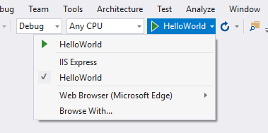

It should show the following window. The application is now self-hosted and will remain active if this process is not shut down.

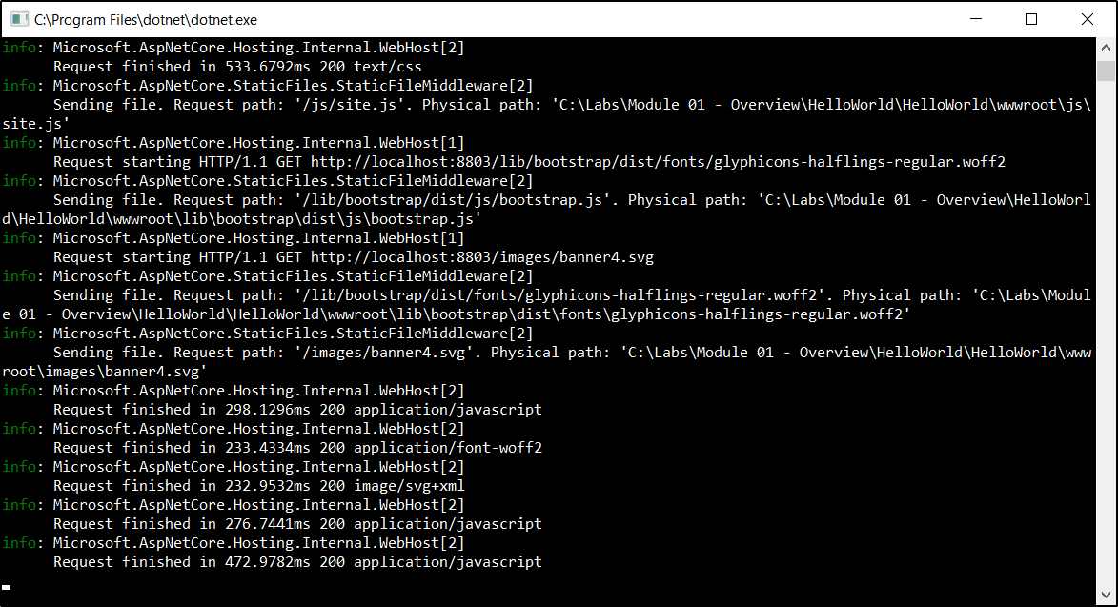

Now, instead of IIS Express – we are directly using Kestrel as web server to host the app.

* 1. Press **Ctrl + C** to shut down the server.

We’ve now finished creating an ASP.NET Core Web Application!

Exercise 2: Middleware

#### Introduction

Middleware are components that are assembled into an application pipeline to handle requests and responses. Each component can choose whether to pass the request on to the next component in the pipeline, and can perform certain actions before and after the next component in the pipeline. Request delegates are used to build this request pipeline, which are then used to handle each incoming HTTP request to your application.

Request delegates are configured using Run, Map, and Use extension methods on the IApplicationBuilder type that is passed into the Configure method in the Startup class. An individual request delegate can be specified in-line as an anonymous method, or it can be defined in a reusable class. These reusable classes are middleware, or middleware components. Each middleware component in the request pipeline is responsible for invoking the next component in the chain, or can opt to short-circuit the chain if appropriate.

#### Objectives

In this exercise, you will:

* Create a custom middleware
* Use extension methods for built-in Static Files middleware

Task 1: Create a Custom Middleware

1. Open Visual Studio 2019.
   1. Create a new ASP.NET Core application project by going to **File** > **New** > **Project.** Select the **ASP.NET Core Web Application** project type, name the project *Middleware*, and then click **OK**.
   2. Choose **Empty** underASP.NET Core templates. Leave other settings to default state. Click **OK**.
   3. Run the application and it should show “**Hello World!”** text in the browser.
   4. Navigate to **Startup.cs** and replace **Configure** method with the following code:

public void Configure(IApplicationBuilder app, IWebHostEnvironment env)

{

app.Run(async (context) =>

{

await context.Response.WriteAsync("Hello World! ");

});

app.Run(async (context) =>

{

await context.Response.WriteAsync("2nd middleware in the pipeline!");

});

}

* 1. When you run the application, it still only shows a single Hello World statement. **Why is the 2nd middleware not executed?**
  2. It is important to realize that the request delegate as written in the first middleware, uses **app.Run()** and will terminate the pipeline, regardless of other calls to app.Run() that you may include. Therefore, only the first delegate (“Hello, World!”) will be run and displayed.
  3. You must chain multiple request delegates together making a different call to app.Use(), with a **next** parameter representing the next delegate in the pipeline. Note that just because you are calling “**next**” does not mean you cannot perform actions both before and after the next delegate. Let us replace the **Configure()** method code with the following:

(Note: changes are highlighted in yellow.)

public void Configure(IApplicationBuilder app, IWebHostEnvironment env)

{

app.Use(async (context, next) =>

{

await context.Response.WriteAsync("Hello World! ");

await next.Invoke();

});

app.Run(async (context) =>

{

await context.Response.WriteAsync("2nd middleware in the pipeline!");

});

}

**Note:** You configure the HTTP pipeline using the extensions **Run, Map**, and **Use**. By convention, the Run method is simply a shorthand way of adding middleware to the pipeline that does not call any other middleware (that is, it will not call a next request delegate). Thus, Run should only be called at the end of your pipeline. Run is a convention, and some middleware components may expose their own Run[Middleware] methods that should only run at the end of the pipeline.

In the above code, the first middleware uses **Use** and the terminating middleware uses **Run**.

* 1. Run the application now. It should show both text lines in the browser.

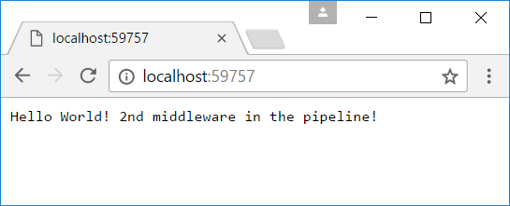

We’ve just finished writing some in-line middleware!

Task 2: Use Static Files Middleware

1. You have created in-line middleware so far. Let us use **Static File** built-in middleware in ASP.NET Core.
   1. Check to see if **Microsoft.AspNetCore.Diagnostics** is part of the Microsoft.AspNetCore.All metapackage under the dependencies node (which it should be). But if it’s not, add the following package **Microsoft.AspNetCore.Diagnostics** to your project via NuGet.
   2. Go to **Startup.cs**, and add the following line at the start of the **Configure()** method:

app.UseWelcomePage();

* 1. Running the application now should show a Welcome page.

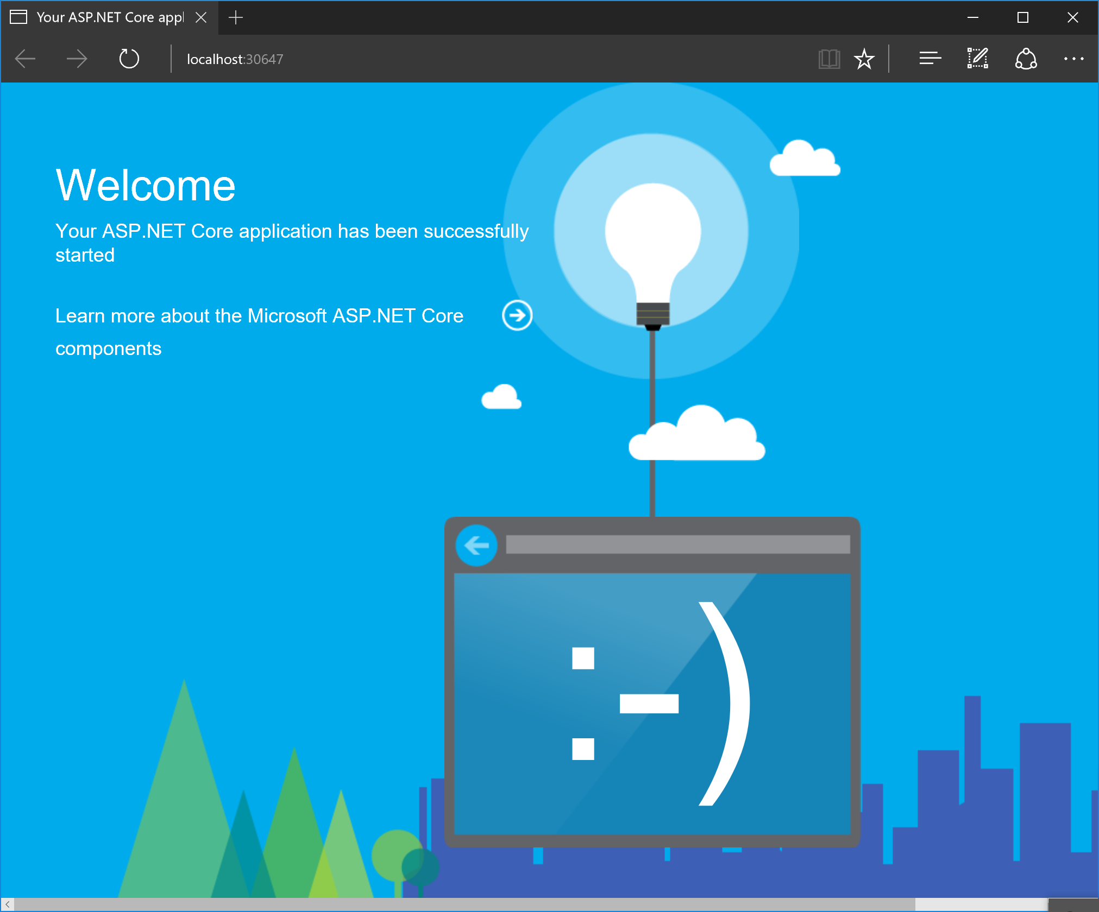

**Important:** The order in which you arrange your **Use[Middleware]** statements in your application’s Configure method is very important. Be sure you have a good understanding of how your application’s request pipeline will behave in various scenarios.

We’ve just successfully used a built-in middleware component!

1. Now let’s look at using statics files:
   1. Add the static files from lab **Assets** folder to **wwwroot** folder. (You can do this by right-clicking **wwwroot** > **Add** > **Existing Item**).

When you’re done, the folder structure should look like the following screenshot (create new folders as needed):

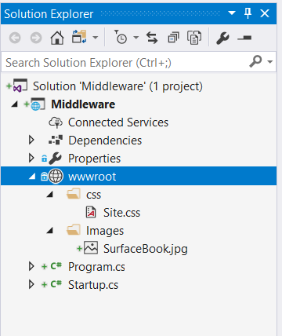

* 1. Add the following NuGet package **Microsoft.AspNetCore.StaticFiles**, if not already added.
  2. Remove or comment out the Welcome Page middleware statement below:

app.UseWelcomePage();

* 1. Add the following line to the start of the Configure() method:

app.UseStaticFiles();

* 1. Run the application and go to:   
     [http://localhost:[YOUR LOCALHOST PORT]**/images/surfacebook.jpg**](http://localhost:XXXX/images/surfacebook.jpg).   
     It will show an **image** of Surface Book.

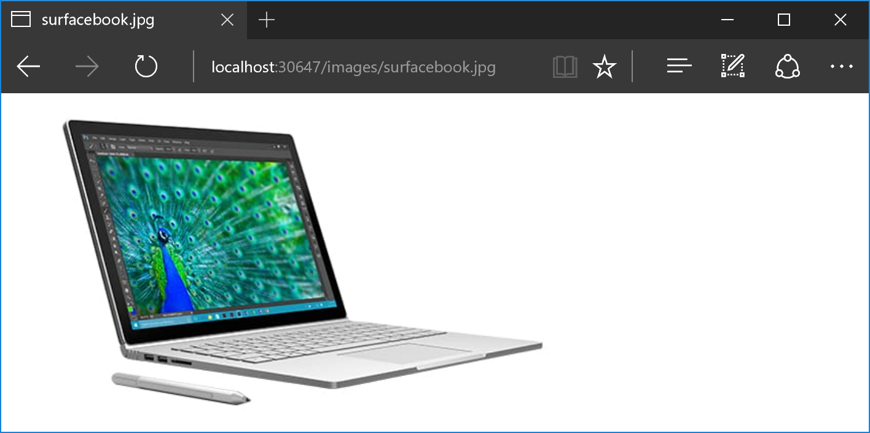

* 1. Similarly, going to: [http://localhost:[YOUR LOCALHOST PORT]**/css/site.css**](http://localhost:[YOUR%20LOCALHOST%20PORT]/css/site.css) will let you download the **CSS** file. **app.UseStaticFiles()** has enabled access of all static files in wwwroot folder.

1. Now let’s restrict access to parts of the static folder.
   1. Replace existing UseStaticFiles() middleware component with the following:

app.UseStaticFiles(new StaticFileOptions

{

FileProvider = new PhysicalFileProvider($@"{env.WebRootPath}\Images"),

RequestPath = new PathString("/img")

});

**Physical folder path:** Make sure that the physical folder path above is replaced with **wwwroot** folder path in your project.

**Note:** Add the following using statements for the above code:

using Microsoft.Extensions.FileProviders

* 1. It will now let you access the image using [http://localhost:[YOUR LOCALHOST PORT]**/img/surfacebook.jpg**](http://localhost:XXXX/img/surfacebook.jpg). However, it will not let you directly download other static files in **wwwroot** folder.

**Note**: If you can still access those files, try opening the Edge browser in private/incognito mode via *Ctrl + Shift + P*. It might be cached in the browser.

We’ve successfully enabled use of our static files in the wwwroot folder, and then restricted access to parts of it!

Exercise 3: Working Environments

#### Introduction

ASP.NET Core introduces improved support for controlling application behavior across multiple environments, such as development, staging, and production. Environment variables are used to indicate which environment the application is running in, allowing the app to be configured appropriately.

ASP.NET Core references a particular environment variable to describe the environment, the application is currently running in. This variable can be set to any value you like, but three values are used by convention: *Development*, *Staging*, and *Production*. You will find these values used in the samples and templates provided with ASP.NET Core.

#### Objectives

In this exercise, you will:

* Configure different pipelines for development and production working environments.

Task Procedure: Create a New Application Pipeline for Development Environment

1. Let’s continue with our *Middleware* project.   
   Create another **Configure()** method in the **Startup** class in **Startup.cs**, and name it *ConfigureDevelopment*. Place this at the end of the file.

public void ConfigureDevelopment(IApplicationBuilder app)

{

}

**Note:** In addition to using an entirely separate Startup class based on the current environment, you can also adjust how the application is configured within a **Startup** class.

The **Configure()** and **ConfigureServices()** methods support environment-specific versions similar to the Startup class itself, of the form **Configure[***Environment***]()** and **Configure[***Environment***]Services()**.

If you define a method **ConfigureDevelopment()** it will be called instead of **Configure()** when the **environment** is set to **development**. Likewise, **ConfigureDevelopmentServices()** would be called instead of **ConfigureServices()** in the same environment.

* 1. It makes sense to give unrestricted access to static files in **Dev** & **Test** environments. Add the following statement to **ConfigureDevelopment( )** method:

app.UseStaticFiles();

* 1. Let us use Welcome page for Dev environment. Add the following statement to **ConfigureDevelopment( )** method:

app.UseWelcomePage();

* 1. Remove the welcome-page and static files middleware from the regular **Configure( )** method.
  2. Modify first middleware’s text to “*Hello World, from Production! <br/>*”.
  3. After all of the above actions, **Startup** class should look like below:

public void ConfigureServices(IServiceCollection services)

{

}

// This method gets called by the runtime. Use this method to configure the HTTP request pipeline.

public void Configure(IApplicationBuilder app, IWebHostEnvironment env)

{

app.Use(async (context, next) =>

{

await context.Response.WriteAsync("Hello World, from Production! <br/>");

await next.Invoke();

});

app.Run(async (context) =>

{

await context.Response.WriteAsync("2nd middleware in the pipeline!");

});

}

public void ConfigureDevelopment(IApplicationBuilder app)

{

app.UseStaticFiles();

app.UseWelcomePage();

}

* 1. Go to project properties and then go to the **Debug** tab. See that ASPNETCORE*_ENVIRONMENT* variable value is **Development**.

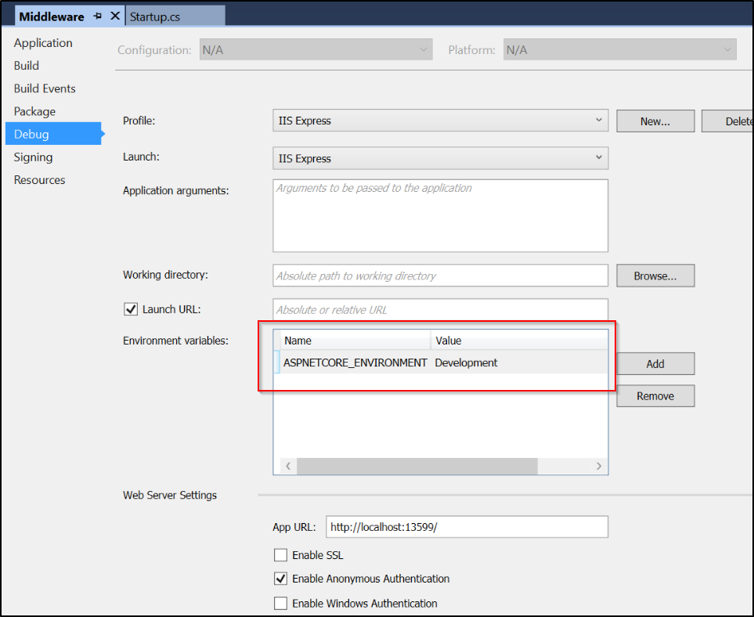

* 1. Run the application. Navigate to any static file URL. As you can see, you have unrestricted access to all static contents.

Navigating to any other URL (such as [http://localhost:[YOUR LOCALHOST PORT]/help](http://localhost:XXXX/help)) in the application will show the **welcome** page.

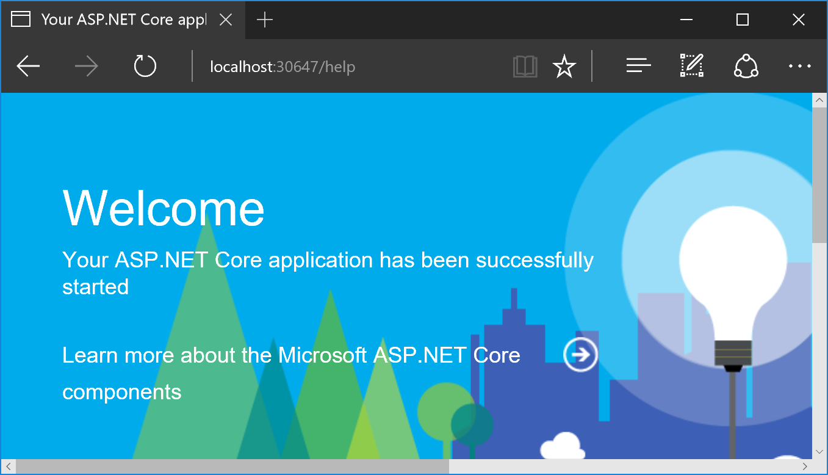

* 1. Go back to project properties in Visual Studio. Set *ASPNETCORE_ENVIRONMENT* variable to **Production**.
  2. Run the application again. Since there is no dedicated **ConfigureProduction( )** method, it will run **Configure( )** method to configure to application pipeline.

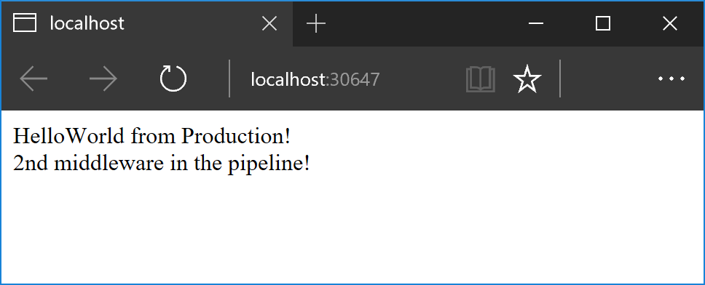

We’ve just configured different pipelines for two different environments - the *development* and *production* environments!